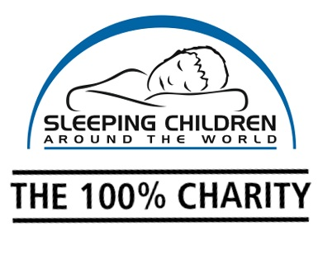

SAVE THE DATE: Sleep Day is ____
Get your colleagues to wear their pyjamas for $5 and
give children living in poverty a better night’s sleep!
Dear ,
On _____, our workplace can have fun and strengthen our corporate community by participating in “Sleep Day”. For this event, the employees can wear pyjamas to work for a $5 donation for Sleeping Children Around the World. Sleeping Children Around the World is a 100% charitable organization based in Canada (no monies donated go to cover overhead costs) that provides bedkits to children in developing countries. Each bedkit includes a sleeping mat or mattress, bedding, a mosquito net to combat the threat of malaria, clothes and school supplies. Check out www.scaw.org for more details.
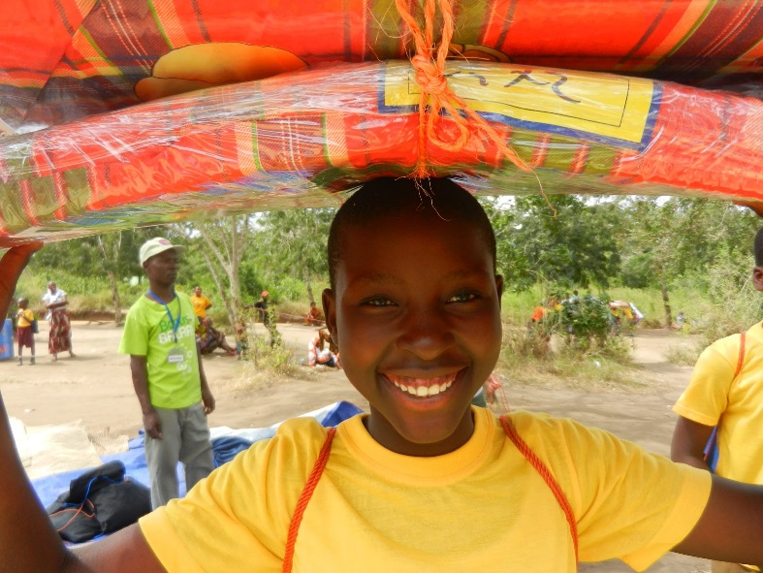
It’s easy to get involved and make a difference:
Mark “Sleep Day” on your company event calendar.

For every $35 in donations collected, you’ll receive a photograph of a child with their new bedkit. The donation will be made in your company’s name & honour.

*have fun while doing good!

We would love to have your support! With your help we can transform the lives of children in developing countries through a good night’s sleep.
Sincerely,
Sleeping Children Around the World

