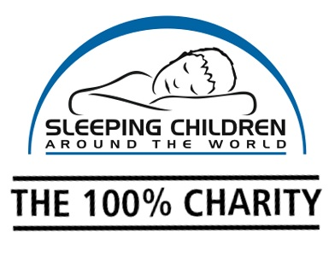

SAVE THE DATE: Sleep Day is _____
Get your students to wear their pyjamas for a toonie &
give children living in poverty a better night’s sleep!
Dear School Administration:
On _____, your school can have fun while raising awareness of the importance of healthy sleep for all children. You can support Sleeping Children Around the World by wearing pyjamas to school for a $2 donation. Sleeping Children Around the World is a 100% charitable organization based in Canada (no monies donated go to cover overhead costs) that provides Bedkits to children in developing countries. Each Bedkit includes a sleeping mat or mattress, bedding, a mosquito net to combat the threat of malaria, clothes and school supplies. Check out www.scaw.org for more details.
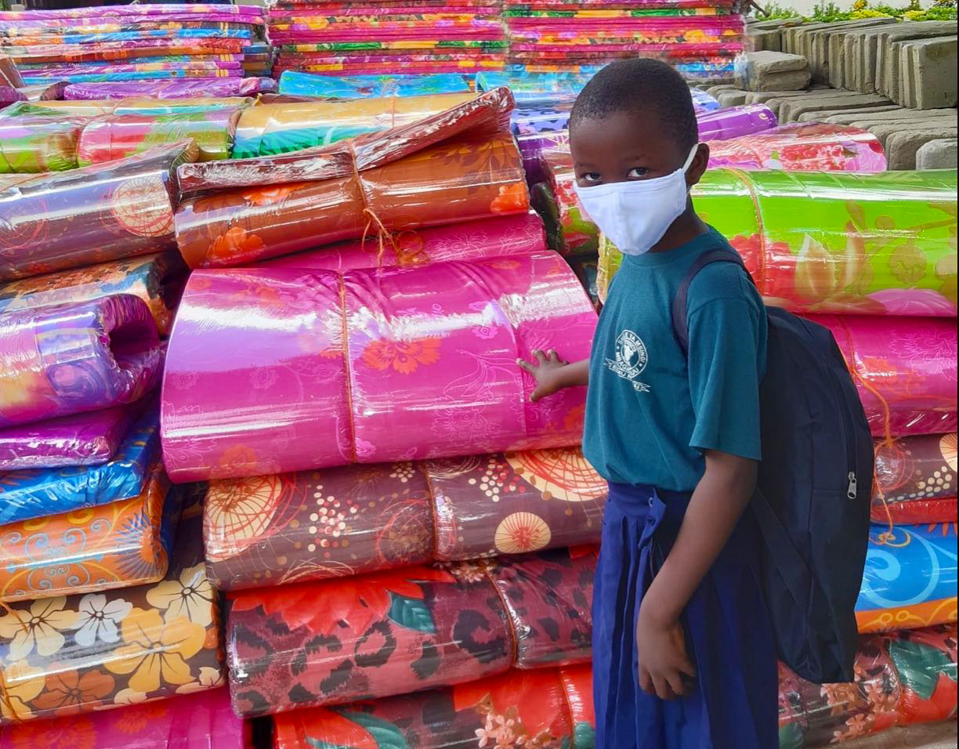
It’s easy to get involved and make a difference:
Mark “Sleep Day” on your school event calendar.

For every $40 in donations collected, you’ll receive a photograph of a child with their new bedkit. The donation will be made in your school’s name & honour.

Have fun while doing good!

We would love to have your support! With your help our Canadian students can transform the lives of children in developing countries through a good night’s sleep.
Sincerely,
Sleeping Children Around the World

