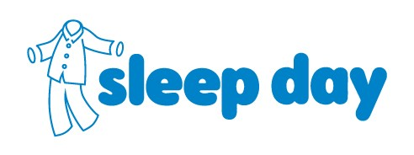
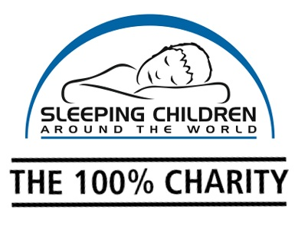

SAVE THE DATE: Sleep Day is December 3rd, 2019
Get your colleagues to wear their pyjamas for $5 and
give children living in poverty a better night’s sleep!
Dear ,
On December 3rd, 2019, Sleeping Children Around the World will be hosting its third annual Sleep Day where you can wear pyjamas to work for a $5 donation. If your workplace participated last year….THANK YOU! Sleeping Children Around the World is a 100% charitable organization based in Canada (no monies donated go to cover overhead costs) that provides bedkits to children in developing countries. Each bedkit includes a sleeping mat or mattress, bedding, a mosquito net to combat the threat of malaria, clothes and school supplies. Check out www.scaw.org for more details.
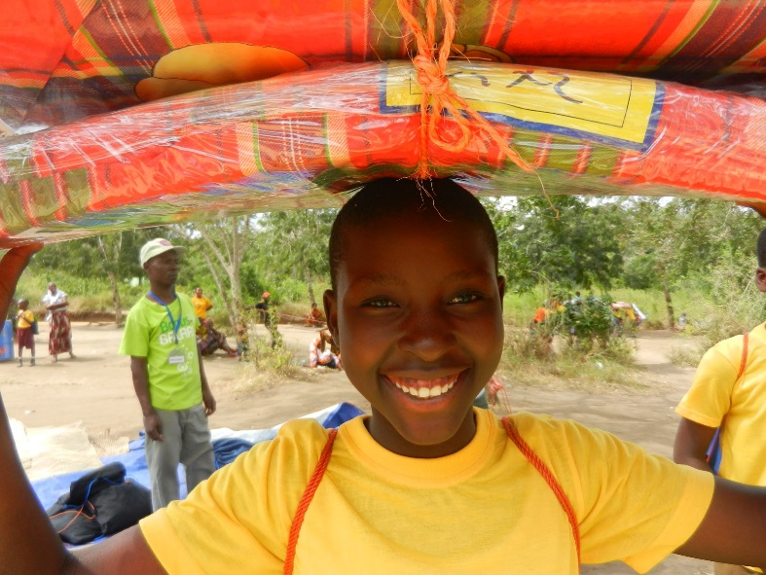
It’s easy to get involved and make a difference:
Mark “Sleep Day” on your company event calendar for December 3rd, 2019.

Visit www.sleepday.ca for posters and communications closer to the event to help create awareness and excitement for Sleep Day.

For every $35 in donations collected, you’ll receive a photograph of a child with their new bedkit. The donation will be made in your company’s name & honour.

We would love to have your support! With your help we can transform the lives of children in developing countries through a good night’s sleep.
Sincerely,
Sleeping Children Around the World

